ASSIGNMENT 9.2
SHRUTHI ADDAGUDI | 2303A52133 | BATCH 37

Task Description -1
Use AI to generate concise functional summaries for each Python function in a given script.
Prompt used:
Generate a short, technically accurate summary for each Python function. Do not explain implementation details. Keep it concise.
Output:
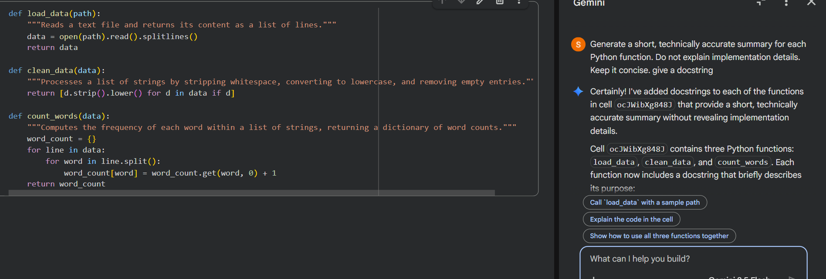
Explanation:
AI generated short docstrings that describe what each function does.
The summaries focus only on the function’s purpose, not how it works internally. Technical wording is used to keep the meaning clear and precise. This improves code readability and helps others quickly understand functionality.

Task Description -2
Use AI to generate concise functional summaries for each Python function in a given script.
Prompt used:
Explain only the decision-making logic and loop behavior.
Skip syntax explanations.
Output:
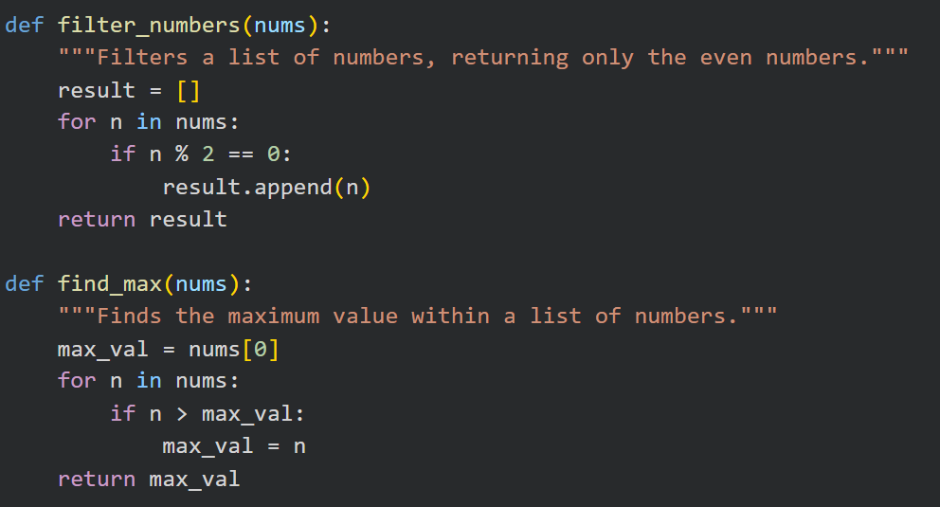
Explanation:
The AI explained the purpose of each loop and how the conditions control the flow of the program. It clearly described what decisions are being made and what happens when those conditions are true. Basic syntax was intentionally skipped to keep the focus on the program’s logic.

Task Description -3
Use AI to generate a high-level overview describing the functionality of an entire Python file.
Prompt used:
Write a brief high-level overview of the entire Python file and place it at the top.
Output:
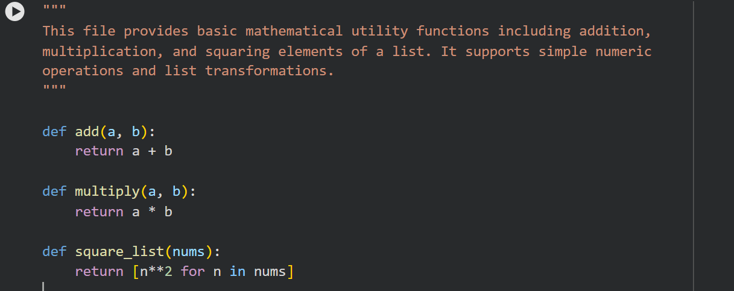
Explanation:
The AI generated a brief overview at the top of the file that summarizes the main functionality. It helps readers quickly understand what the entire program does without reading every function.
Task Description -4
Use AI to improve clarity and consistency of existing documentation in Python code.
Prompt used:
Improve clarity and consistency of the existing comments without changing meaning.
Output:
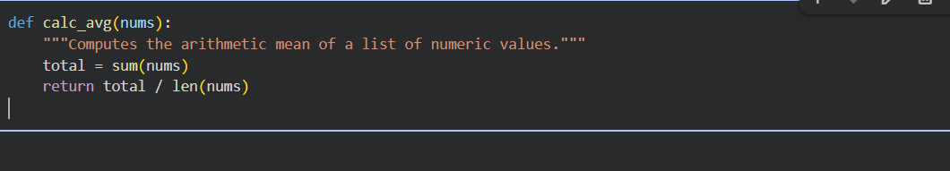
Explanation:
AI Replaced vague comments and used consistent docstring format
And maintained original functionality.
Task Description -5
Study the impact of prompt detail on AI-generated documentation
quality.
Prompt 1:
Write a short documentation comment for this function.
Output:
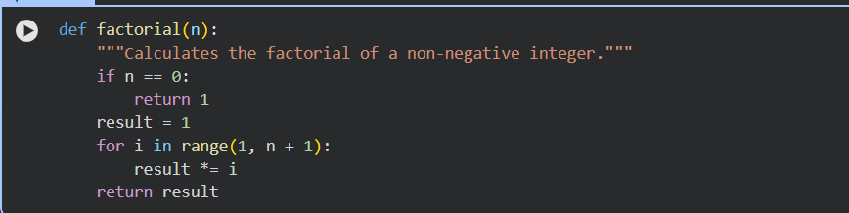
Prompt 2:
Write a clear docstring explaining the purpose, input, output, edge case, and behavior of the loop. Do not include implementation details.
Output:
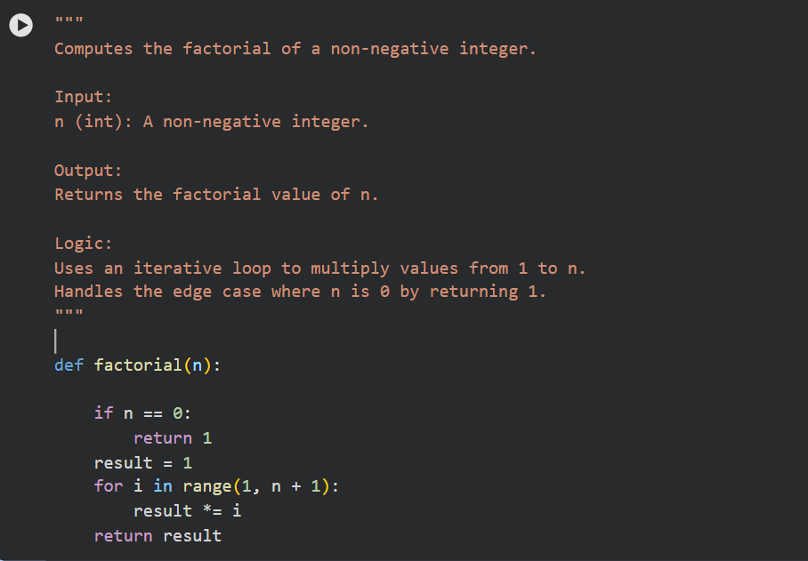
Comparison Table:
Criteria | Brief Prompt Output | Detailed Prompt Output
Completeness | Minimal | High
Clarity | Basic | Very clear
Accuracy | Correct | Correct
Edge Cases | Not mentioned | Included
Loop Behaviour | Not described | Clearly described
Usefulness | Low | High

